How do I use your models, Shreyas?

It’s easy provided you know the basic concepts of how various different electrical components such as resistors, capacitors and inductors work (very easy to understand by the way) and of course you have MATLAB with the entire SIMSCAPE toolbox included. (Any version including and above 2013a is guaranteed to work with these models)

I’ve opened these models, now what do I do?

Good! Now you don’t need to do much actually. First double click on the scopes

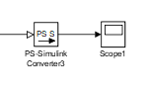

Now, in the following window, click on the “settings” button

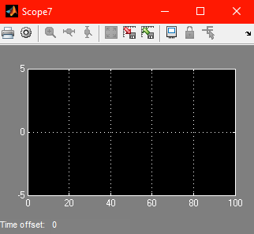

Now, in the settings dialog box, uncheck the first box and check the second one as shown,

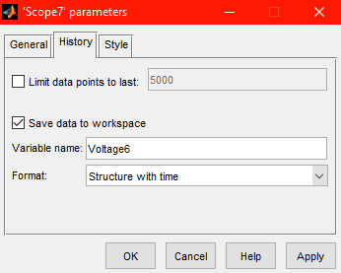

Don’t change anything else (except the variable name which must be relevant to the kind of parameters you’re measuring(For e.g. name it “Voltage” if you’ve connected the scope to a voltage measurement/sensor block)) unless you’re really good at MATLAB. (If you were then you’d have ignored every line that I’ve written until now :P)

And don’t forget to do all the steps mentioned above for each and every scope. (And don’t forget the variable name)

Shreyas, I’ve done all that, now wtf I do?

Great! Now just click on the “run” button. (The one that looks like a play button)



You can adjust the simulation time to whatever value you want(I’ve taken it as 100s, you can take as much or as little as you want)

Then what?

Double click each of the scopes et voila! You’ll see a graph depicting the variation of the parameter measured by the corresponding sensor blocks w.r.t time.

Anything else?

Hold on to your arse! Just one more thing left, open the command window now and type the following command(s).

scatter(VariableName.signals.values, VariableName.signals.values) (the one on the left is for the x values (voltages) and the one on the right is for y values (charges))

Now, you’ve got a scatter plot that gives you the variation of charge w.r.t voltage for any of the mentioned values of temperature mentioned in this set.

{253K, 273K, 293K, 313K, 333K, 353K}